AS91887 – Iterative Processes for a digital outcome

Name: Josh Dean
Teacher: Mr Sutherland

Outcome Development
Please state your outcome here:
2D rhythm game

Relevant Implications
Examples are: social ● cultural ● legal ● ethical ● intellectual property ● privacy ● accessibility ● usability ● functionality ● aesthetics ● sustainability and future proofing ● end-user considerations ● health and safety.
Implication | Description of a relevant implication and how it is relevant. | Explain why the implication is important and how you plan to address it. | How you have met the implication.
Usability | Usability allows products to easily be understood by the user, this is relevant to my project as users need to be able to easily play my game. | This implication is important as it allows users of products to easily understand what a product does and how to use it. I plan on addressing this by using conventions from other rhythm games to make the users know how to play without much help.
Functionality | Functionality allows products to work as intended, this is relevant to my project as if it doesn’t work as intended users wouldn’t want to play my game. | This is important to my game as it determines if the game works as intended. I’ll be addressing this by testing my game constantly throughout development to make sure it’s functional.
Aesthetics | Aesthetics make products appealing to consumers, this is relevant as if my game isn’t appealing to users then they’ll be less likely to play. | This is important to my game as it determines how users will view it, quite literally as it’s what they’ll be looking at. I’ll be addressing this by making sure the artwork used is clean and readable with being arranged in a way that allows it be pleasing to the eye.
Accessibility | Accessibility makes sure that products are accessible for all types of users to use. This is relevant to my project as many different types of users would likely play my game, this means that I’ll need to make it usable for all types of players who would play my game. | This is important as it allows players to have the best experience that they can while playing my game. I’ll be addressing this by making sure that there’s things in place to make the experience better for as many people as I can, such as making sure that there is little to no flashing lights or a toggle for them for people with epilepsy.

Planning and Project Management tools
List the project/planning tool that you used, and describe it. Describe how often you used it and give evidence as to its use (Screenshots).
Project management tools/techniques:
Saving backup copies with a logical naming system, using collaboration tools, simple version control software applications (required merit), using tools or systems to plan tasks and milestones, adjusting key actions and tasks where appropriate.

Project Management Tool: Gantt Chart
Using tools or systems to plan tasks and milestones
Description: | A chart that allows planning and organization of tasks
How often did you use it: | Whenever significant updates to the progress of the game are made.
Evidence 1: | 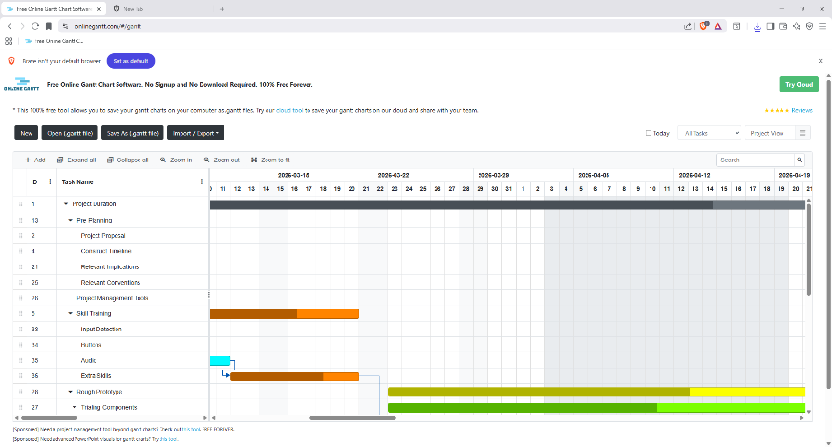  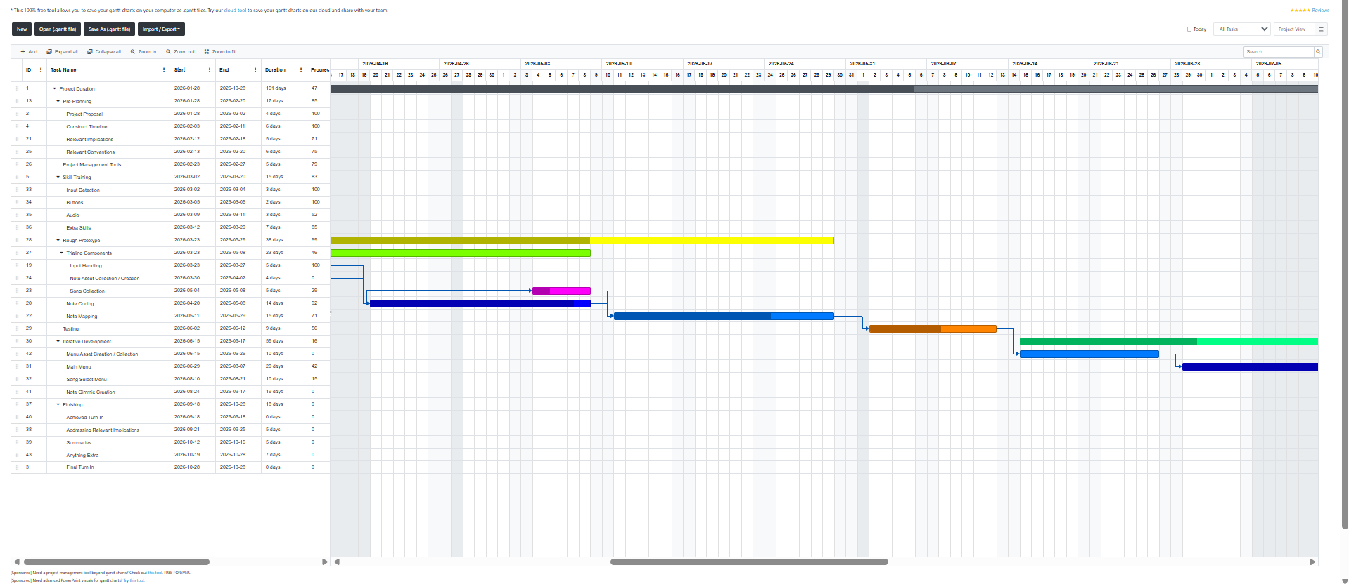  *Add 3rd image of evidence*
Evidence 2:
Evidence 3:

Project Management Tool: Version Control Tool: Github
Description: | Allows the viewing of different versions of a project which can be restored and branched off of to create different versions of the same project.
How often did you use it: | At the end of each session of modifying the project.
Evidence 1: | 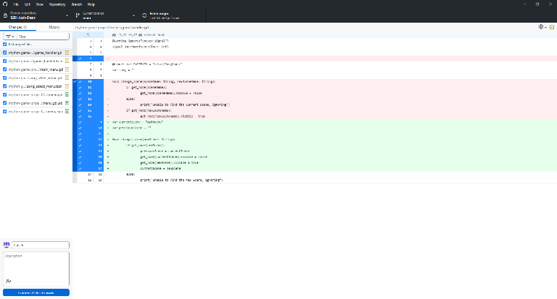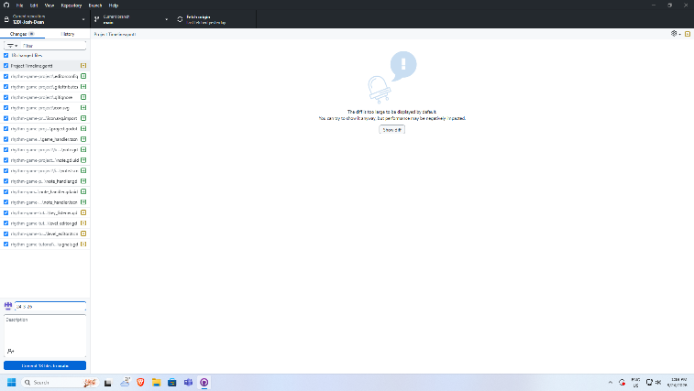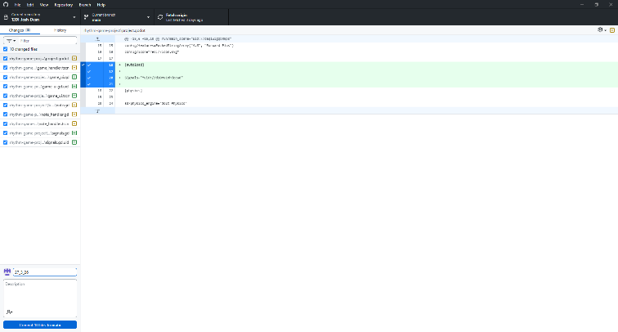
Evidence 2:
Evidence 3:

Project Management Tool:
Description:
How often did you use it:
Evidence 1:
Evidence 2:
Evidence 3:

Smaller Components
Break your outcome into smaller components and list them here:
e.g. Storyboard, Intro, Drone footage, interview footage
Component | Description
Main Menu | The look and functionality of the main menu of the game. (Does it do what’s expected?)
Song Select Menu | The look and functionality of the Song Select menu of the game. (Does it look appealing and intuitive to use?)
Game Note functionality | The way a note acts when in gameplay. (Does the timing feel off? Should hitting areas be larger or smaller?)
Editor Note functionality | The way the editor notes function. (Is it convenient? Does it feel clunky to use?)
Score | The score of the player during gameplay.
Visuals | The look of the game. (Is it consistent, is it readable, is it user friendly?)
Song Maps | How readable the song maps are to the player. (Notes too fast, pattern confusing)

Trialling multiple components
Merit: trialling multiple components and/or techniques and selecting those which are most suitable
Component:
Component/Technique | Component/Technique | Component/Technique
Selected Component:
Why:

Component:
Component/Technique | Component/Technique | Component/Technique
Selected Component:
Why:

Component:
Component/Technique | Component/Technique | Component/Technique
Selected Component:
Why:

Trialling Components
List the component, do testing and seek feedback, then make changes to the component, repeat this process 4 times for each component.
Component 1: Editor Notes
Component Link/ File Name: Editor Note  Found in “GifEvidence/EditorNote” if gifs don’t work. | Testing/Feedback | Changes to be made
 | On hover it doesn’t give any indication it’s being selected. | Add indication for main note hovering
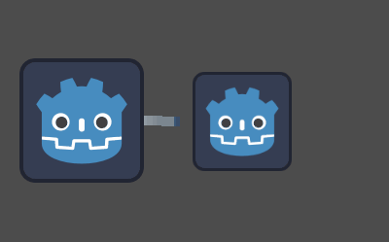 | Size of drag note hitbox is too large. | Reduce the size of the drag note hitbox to be more readable
 | When constantly smaller, the drag note is unable to be held because of the main note blocking it. | Make the hitbox only smaller when outside of main note’s range.
Placeholder Textures:  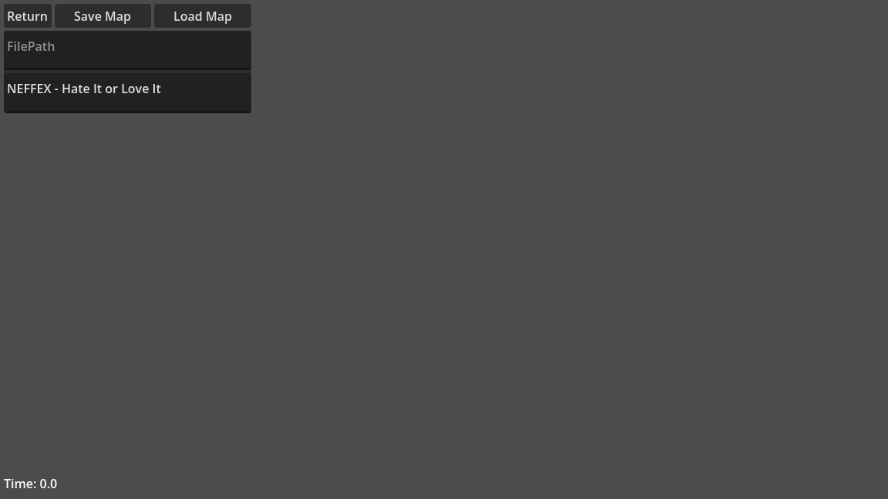  Proper Textures:  Add evidence of proper textures in game!!!! | Placeholder textures are still in-game. | Change the placeholder textures to actual textures.

Component 2:
Component Link/ File Name: Game Note | Testing/Feedback | Changes to be made
Add Evidence of this!!! | Doesn’t move across screen | Add movement to the notes
 | Input doesn’t work | Add input to “hit” the notes
 | No feedback on hitting a note | Add feedback when hitting note: score increases, note disappears
 | Hold notes act like regular notes | Add proper functionality for hold notes

Component 3:
Component Link/ File Name: Game menus | Testing/Feedback | Changes to be made
Add Evidence of this!!! | Button’s don’t do what they seem like they should. | Make buttons do what they’re supposed to
 | Placeholder textures are still in the game | Update textures to better represent the game
 | No background music | Add quiet background music to increase immersion for the player
 | Little to no player feedback on actions. | Add feedback to player actions: hover sound, buttons visually changing to show being “active” (Can be pressed)

Component 4:
Component Link/ File Name | Testing/Feedback | Changes to be made

Testing Final Outcome
Please provide a link or location information to your final outcome here prior to testing:

Testing
Test | Description | Changes to be made
Spelling Errors:
Grammar Errors:
Credits:
Audio problems:
Video problems:
Understandable:
Aesthetics:
Culturally/socially
appropriate:

Final Outcome after Testing
Please provide a link or location informaiton to your final outcome after testing has been completed:

Include a couple of statements supporting how the functionality has been improved due to testing and trialling:

Final Analysis:

Discussion Framework
For this section you must Discuss how the information from planning testing and trailing of components assisted in the development of a high quality outcome.
A discussion is a weighing of the pros/cons or critically looking at your work from another point of view. For example, the evidence shows how the student used information and a range of sources, such as user feedback, trialing, and research to develop a high-quality outcome.
I.e. I researched x and found this, I got feedback on x and found this. This information was conflicting I choose to trial both x and see the pros and cons. Here is what happened when I tried Y here is what happened when I tried Z. I believe that the highest quality outcome was Y for these reasons.
All points must be relevant to the development of a high quality outcome.
Planning:
Information gained from planning:
1.)
2.)
3.)
How did this information assist in the development of a high-quality outcome?

Trailing:
Information gained from trialing:
1.)
2.)
3.)
How did this information assist in the development of a high-quality outcome?

Testing:
Information gained from testing:
1.)
2.)
3.)
How did this information assist in the development of a high-quality outcome?

